Say No To Corruption
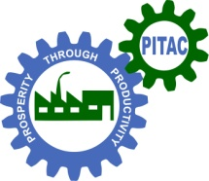 |  | Ministry of Industries & Production
Plumber and Pipe Technician
25% Discount for Females
Key Objectives
- In this course, you will learn all aspects of the Plumbing and Pipe fitting trades as they apply to Residential, Commercial and Industrial construction. All instruction is in accordance with the American Standard National Plumbing Code.
Course Outline
- Plumbing and Pipe Lines Trouble Shooting. 100% Practical Base Course PPR,UPVC, CPVC, PAP,PE, GI, MS, DI, FRP, AC Pipes Related instruction in Plumbing mathematics and blueprint reading are included as well as a variety of laboratory and field projects to provide actual practice situations.
After Course Benefit(s)
- Approved apprenticeships are also available for qualified students.
Days: Three Days a week Class Timing: 9:30 AM – 01:30 PM
Duration: 6 Weeks Start Date: 10th April, 2017 Fee: Rs. 7,875.
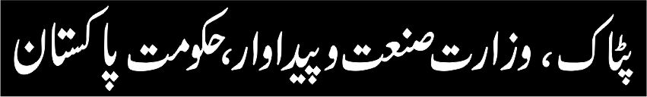
Ph: 042-99230701, 99230699 Email: training@pitac.gov.pk
Website: www.ptiac.gov.pk
SIZE: 2 COL X 10 CM
To be published in Daily
“Jang” Lahore Edition,
on Sunday 2nd April, 2017

